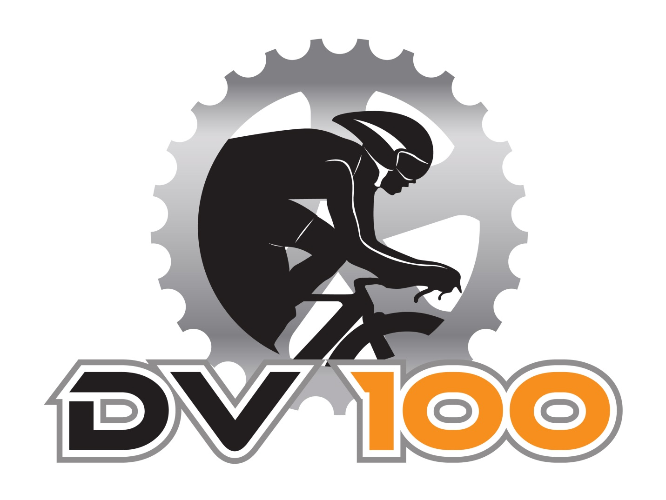

September 11th, 2021

SCHEDULE OF EVENTS
Friday, September 10, 2021
5:00 p.m. to 8:00 p.m. Participant package pick up and registration at Ramada Hotel
Volunteer registration at the Ramada Hotel
Wine and Cheese at the Ramada Hotel for participants, volunteers and guests
Ramada Hotel – 2051 50 Street, Drayton Valley, AB
Saturday, September 11, 2021
Drayton Valley Omniplex – 5737 45 Avenue, Drayton Valley, AB
7:00 a.m. – 8:45 a.m. Participant package pick up and registration
8:00 a.m. 160km Race/Ride begins
9:00 a.m. 20km, 40km, 100km Race/Ride begins
2:00 p.m. Awards
2:30 p.m. Course officially closes
5:30 p.m. DV100 After Dark party (tickets are required)

Onsite attractions will include:
Live Music, Food Trucks, Beer Gardens, Farmers Market, Specific Photo Area, Onsite registration for next year; Athlete designated area which will include massage, cooldown pool, mats and rollers

NOTE 160Km riders: you can leave a bag with our volunteer on Saturday morning that will be at the 160km turn around point which is at about 100km. You may want to include some nutrition, clothing or whatever you think you may need. You will get your bag back once the race/ride is completed and our volunteer makes it back to the finish line.

20KM ROUTE
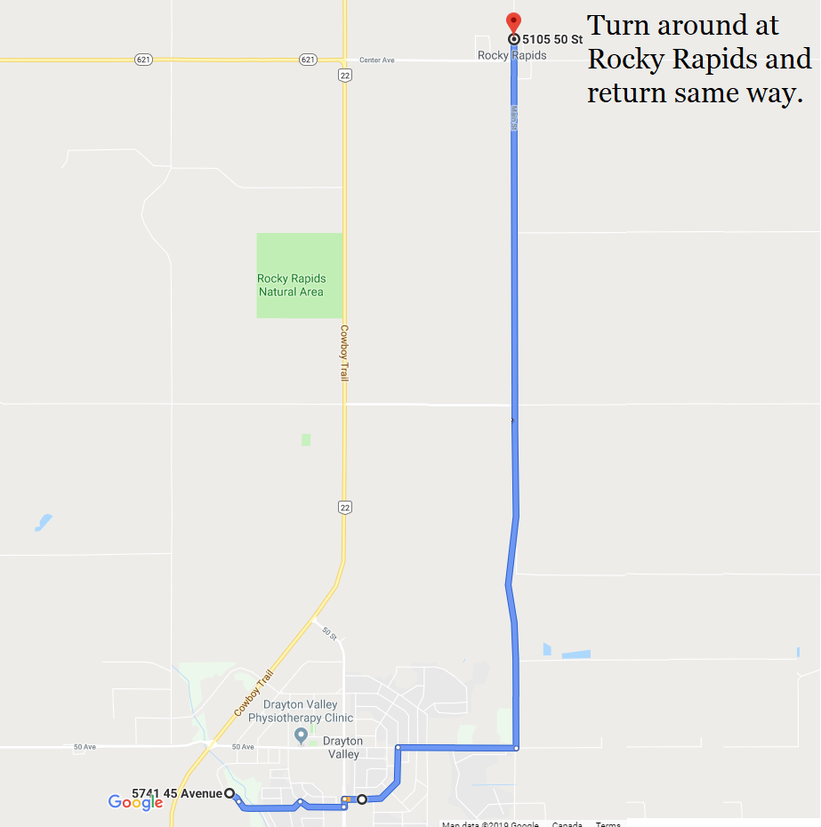

40KM, 100KM ROUTE
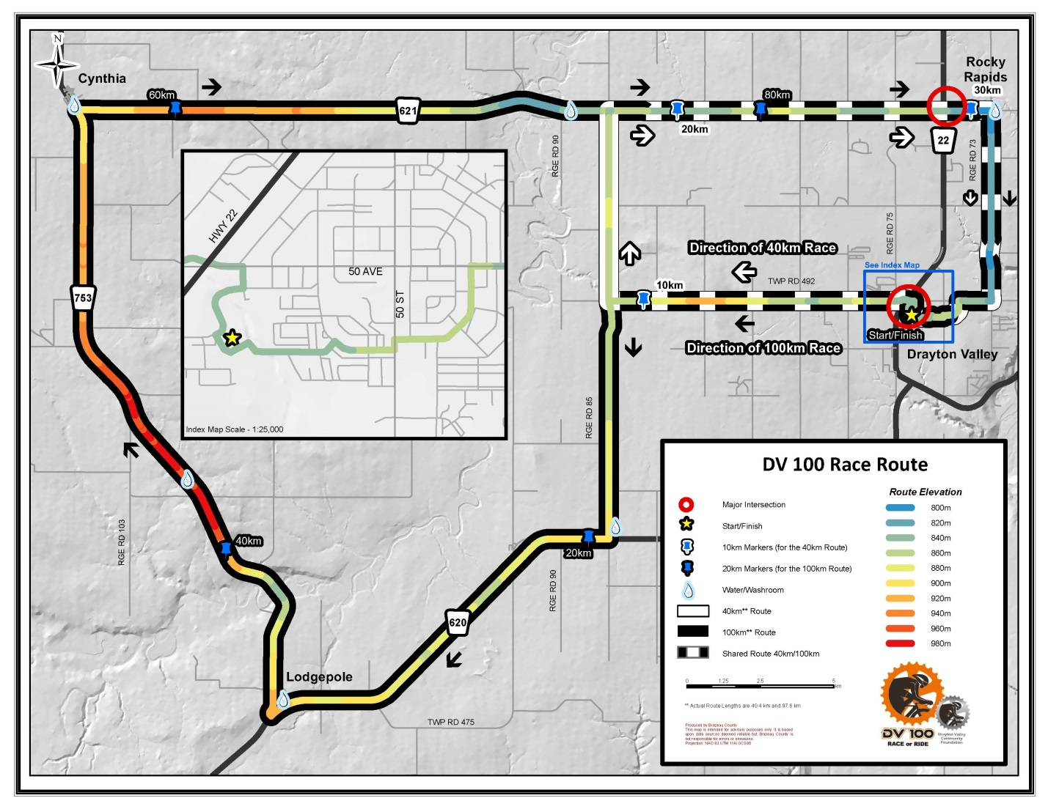

100KM ROUTE PROFILE
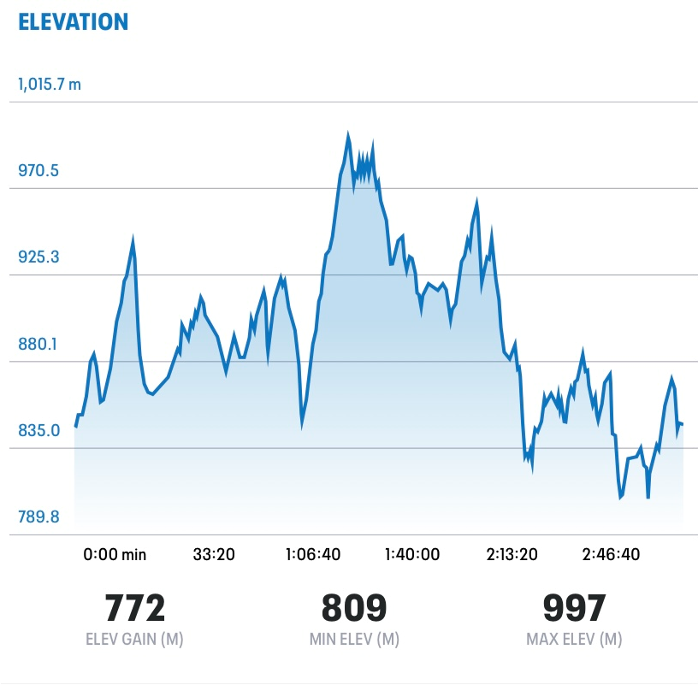

160KM ROUTE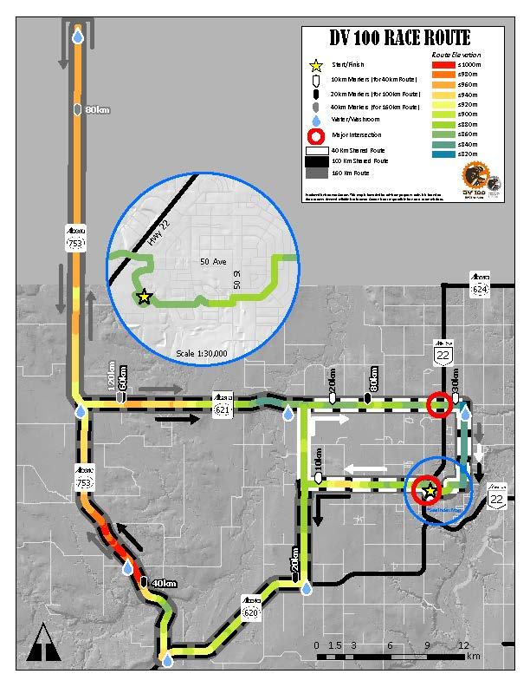

DV100 Race/Ride Rules

- All decisions made by DV100 Race or Ride are final.
- Helmets are mandatory. An approved cycling helmet is required. Cyclists must wear a certified cycling helmet with the chinstrap buckled at all times while riding on the course.
- Ride within the designated routes. Ride safely and in control and single file whenever possible. Any cyclist who is deemed to be riding unsafely, discourteously or recklessly will be removed from the DV100 Race or Ride. Any riders found cycling outside the designated cycling lane for the DV100 Race or Ride will be automatically disqualified.
- No outside support vehicles allowed along the course. Support vehicles and spectators are allowed in designated areas only. It is unsafe for spectators to stop at any other spot along the route.
- Emergency Vehicles ALWAYS have the right of way. If a rider encounters an emergency vehicle, the rider is to give way to the emergency vehicle by pulling over, stopping and dismounting.
- Display your event number. All registered cyclists must wear their event number according to race instructions.
- Familiarize yourself with the route. It is the responsibility of the riders to know the proper routes. DV100 does provide signage, as well as volunteers to assist riders along the route, but it is up to the rider to ensure they are on the proper route.
- No unregistered individuals. Unregistered riders will not be allowed on course during the event.
- Participants are permitted to use standard road bicycles, hybrids, commuters or mountain bikes. If you are interested in participating using any vehicle other than the standard road bicycle, we require that you contact us no later than one month in advance of the event.
- Triathlon bikes and road bikes with aero bars are not allowed to draft on any route. Triathlon bike riders are only eligible for prize money in the 160KM.
- No usage of headphones, personal stereos or cell phones while riding.
- DV100 Race or Ride riders under the age of 18 on race day must have their waiver agreed upon by a parent or guardian in order to participate.
- Riders must be a minimum of 16 years old to participate in DV100 Race or Ride.
- Course closure. Riders will need to be finished the course by 2:30pm. After 2:30pm there will be no volunteers or support vehicles to assist riders.
- No littering on course. Riders are to dispose of garbage in designated garbage bins only.
- All riders are to obey traffic officers and course marshals. To disobey instructions from these individuals may result in disqualification from the ride.
- Public urination is not permitted. When nature calls, riders are asked to use the available portable toilets provided at Rest Stops.
- All decisions regarding prizes are at the discretion of the DV100 Organizing Committee. In the different events if participants are racing the first racer to cross the finish line will receive first place.
- Riders must be present to accept prizes. DV100 will not send prizes to riders after the event is completed.

GUIDELINES
- Be aware of others around you and communicate well in advance while cycling. Use gestures in combination with verbal commands. Pass on the left only. It is recommended that cyclists advise others that they are about to pass – politely saying “on your left” upon approaching a rider usually does the trick. Ride with your head up. Look down the road not at the person in front of you.
- If you choose to stop while on course, signal to the riders behind and pull over safely. Our on-course support team (mechanics, ride marshals, medical staff) may ask you to indicate whether or not you need assistance. If you’re okay, the signal with a “thumbs-up” to say, “Everything’s good with me.”
- Maintain control and speed of your bike, even going downhill.
- Know your limits. Crashes can occur when inexperienced riders do not have bike-handling skills to make quick decisions in a pack.

DV 100 RACE/RIDE - FREQUENTLY ASKED QUESTIONS

- What does DV100 support?
DV100 is a fundraiser for the Drayton Valley Community Foundation. The DVCF exists to serve the community of Drayton Valley and surrounding area. Individual and corporate endowment funds are created where the principle is never spent but the invest income is granted out to community groups and organizations. In the past five years the Drayton Valley Community Foundation has granted out close to $350,000.

The DV100 Fund is another fund that we have where the proceeds from DV100 Race or Ride go into the fund and the investment income is granted back to our community.

- What are your different routes?
- 20KM
- 40KM
- 100KM
- 160KM
- 100KM Team Challenge

- How much does it cost to enter?
Depending on when you register you will pay different amounts; prices go up after May 31 and August 15 for individual riders
- 20KM Before May 31 $60, May 31-August 15 $80, after August 15- $90
- 40KM Before May 31 $90, May 31-August 15 $110, after August 15- $120
- 100KM Before May 31 $100, May 31-August 15 $120, after August 15- $130
- 160KM Now-May 31 $120, May 31-August 15 $130, after August 15- $140
- 100KM Team Challenge Before August 15- $880, after August 15- $930

- What do you get when you enter?
- A very well organized event with 170+ volunteers, support vehicles, aid stations and mobile mechanics
- You get a $50 tax receipt
- DV100 Finishers price
- DV100 Swag
- Hamburger or hotdog after your ride
- Athlete designated area with massage, cool pool, mats, rollers, etc.
- A beautiful ride amongst the beauty in Brazeau and Parkland County’s

- What are the prizes?
- Each category has a prize money, the 100KM event is our most popular and pays out over $10,000
- In total, we are paying out over $20,000
- $1000 to male and female if 100KM course record is broken
- Cyclers must be present at the awards ceremony, which takes place around 2:00 to win prize money, DV100 will not send prize money out after the event

- How many years has this been going on?
- 2019 will be our 8th year
- When we started in 2012 we only had about 40 riders and this year we are aiming for 400!

- What is the route terrain like?
- The route is rolling terrain, there is a large hill between Lodgepole and Cynthia that has an elevation increase of approx. 140m or 500 ft. the hill goes on approx. 12KM
- There are rest stops all along the routes that have washrooms available
- Several trucks patrol along the routes in the event a cycler needs help, or would like a ride back to the start/finish area
- Over 120 volunteers are along the route to direct cyclers as well as KM markers along the route

- What is the start time?
- For the 100KM, 40KM & 20KM routes it is a mass start at 9:00am.
- We encourage all racers to go to the front and riders line up behind them
- Every cycler gets a time, which does not start until they cross the start line
- For the 160KM the start time is 8:00am

- Is this a race or a ride?
- It is both!
- We give away over $25,000 in prize money for racers, which consist of about 10-15% of the cyclers, the remaining 85-90% are riders
- We have tons of participant prizes that are handed out at the end of our event, including cash prizes, and cycling gear

- Are Tri Bikes allowed?
- Tri bikes are allowed in our event
- In the 20KM, 40KM and 100KM tri bikes are allowed, but the cycler is not eligible for prize money nor are they allowed to draft
- The 160KM, tri bikes are allowed and eligible for prize money but may not draft, if a tri bike rider is caught drafting there will be a 5 Minute penalty imposed on their time. Road bikes may draft.

- How old do I need to be to register?
- 16+. You can register at 15 years of age if you will be 16 years of age by December 31, 2019.

- Are there things to do for people who are not cycling during the event?
- We have beer gardens set up on site for those who would like a refreshing beverage during or after the event
- Live Music on site
- Vendor tents are set up on site as well as a food truck
- Most riders are back by 1:30 or 2:00 and then awards are handed out after that

- What about the DV100 After Dark Party
- DV100 After Dark Party takes place after the DV100 event, it is at the same location just moved inside to the Mackenzie Conference Center
- Tickets are $45 and includes supper and live music performed by Oil City Sound Machine
- Doors open at 5:30, supper is at 6:30 and the live band starts at 8:00

